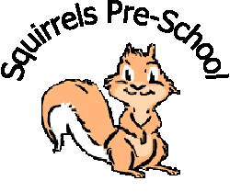
Squirrels Pre-School Rugby Ltd
^{c}/_{o} Paddox Primary School
Fareham Avenue
Rugby
Warwickshire
CV22 5HS

01788 576167

Preschool.s@welearn365.com

www.squirrelspreschoolrugby.co.uk

Training Policy

A Unique Child | Positive  Relationships | Enabling  Environments | Learning and  Development
Keep children safe | Support | Value learning | Active Learning
In order to ensure that the best possible care and education be provided for the children in our care, staff are encouraged to regularly attend training courses to update their knowledge.
We provide regular in-service training to all staff whether paid staff or volunteers.

- Our pre-school budget allocates resources to training.

- We provide staff induction training in the first week of employment. This induction includes our Health and Safety Policy and Safeguarding Children Policy. Other policies and procedures will be introduced within an induction plan.

- We support the work of our staff by holding regular supervision meetings and appraisals.

- Refresher courses are available through Warwickshire Early Years and other training providers to bolster staff knowledge of new legislation and practices and to ensure the continuation of certificates such as Paediatric First Aid, Food Hygiene etc

We receive course information from Warwickshire Early Years and Pre-School Learning Alliance, also seeking out appropriate courses not available by either of the above.

This policy was adopted by the board of directors of Squirrels Pre-School Rugby Ltd

on……23rd September 2024……………………………………………………………………………

Signed on behalf of the Board of Directors……….…………………………………………………………

Signed by Manager………………………………………………………………………………….

Date of policy review………September 2025………………………………………………………………
Signed copy held in setting
Page 1

